Seychelles

## GNI per capita and development level

The data set shows the GNI per capita and development level of the country each year.

## # A tibble: 19 x 5  
## country iso3c date GNIperCapita devCategory   
## <chr> <chr> <dbl> <dbl> <chr>   
## 1 Seychelles SYC 1996 4538. Upper Middle Income  
## 2 Seychelles SYC 1998 4591. Upper Middle Income  
## 3 Seychelles SYC 2000 4591. Upper Middle Income  
## 4 Seychelles SYC 2002 4591. Upper Middle Income  
## 5 Seychelles SYC 2003 4591. Upper Middle Income  
## 6 Seychelles SYC 2004 4591. Upper Middle Income  
## 7 Seychelles SYC 2005 4591. Upper Middle Income  
## 8 Seychelles SYC 2006 4591. Upper Middle Income  
## 9 Seychelles SYC 2007 4591. Upper Middle Income  
## 10 Seychelles SYC 2008 4591. Upper Middle Income  
## 11 Seychelles SYC 2009 4591. Upper Middle Income  
## 12 Seychelles SYC 2010 10224. Upper Middle Income  
## 13 Seychelles SYC 2011 4591. Upper Middle Income  
## 14 Seychelles SYC 2012 4591. Upper Middle Income  
## 15 Seychelles SYC 2013 8612. Upper Middle Income  
## 16 Seychelles SYC 2014 4589. Upper Middle Income  
## 17 Seychelles SYC 2015 4589. Upper Middle Income  
## 18 Seychelles SYC 2016 4589. Upper Middle Income  
## 19 Seychelles SYC 2017 4589. Upper Middle Income

## GDP growth and economic growth classification

The data set shows the GDP growth and the ecomic growth classification of the country each year.

## # A tibble: 19 x 5  
## country iso3c date GDPannualGrowthRate GDPgrowthCategory4  
## <chr> <chr> <dbl> <dbl> <fct>   
## 1 Seychelles SYC 1996 4.92 moderate growth   
## 2 Seychelles SYC 1998 8.40 fast growth   
## 3 Seychelles SYC 2000 1.51 slow growth   
## 4 Seychelles SYC 2002 1.21 slow growth   
## 5 Seychelles SYC 2003 -5.89 negative grwoth   
## 6 Seychelles SYC 2004 -2.85 negative grwoth   
## 7 Seychelles SYC 2005 9.01 fast growth   
## 8 Seychelles SYC 2006 9.41 fast growth   
## 9 Seychelles SYC 2007 10.4 fast growth   
## 10 Seychelles SYC 2008 -2.15 negative grwoth   
## 11 Seychelles SYC 2009 -1.11 negative grwoth   
## 12 Seychelles SYC 2010 5.95 fast growth   
## 13 Seychelles SYC 2011 7.89 fast growth   
## 14 Seychelles SYC 2012 1.26 slow growth   
## 15 Seychelles SYC 2013 6.02 fast growth   
## 16 Seychelles SYC 2014 4.50 moderate growth   
## 17 Seychelles SYC 2015 4.94 moderate growth   
## 18 Seychelles SYC 2016 4.56 moderate growth   
## 19 Seychelles SYC 2017 4.38 moderate growth

## Development trend

The plot shows the development trend of the country.

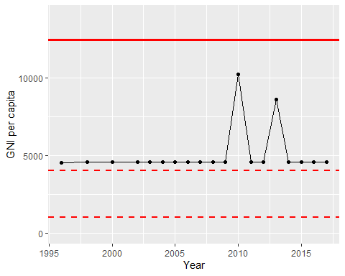

GNI Per Capita Trend